University Of Engineering and Technology, Lahore Computer Engineering Department

Course Name: PF | Course Code: CMPE-112L
Assignment Type: LAB | Dated: 20 April 2026
Semester: 1st | Session: 2026 Spring
Lab/Project/Assignment #: 6 | CLOs to be covered: CLO2
Lab Title: Local and Global Variable | Teacher Name: Hafiz Muhammad Mubashar

Lab Evaluation:

CLO1 | Apply appropriate programming techniques to create executable programs to solve well defined problems
 | Level1 | Level2 | Level3 | Level4 | Level5 | Level6
(5)
Total |  |  |  |  |  | /5

Rubrics for Current Lab Evaluation

Scale | Marks | Level | Rubric
Excellent | 5 | L1 | Submitted all lab tasks, BONUS task, have good understanding.
Very Good | 4 | L2 | Submitted the lab tasks but have good understanding
Good | 3 | L3 | Submitted the lab tasks but have weak understanding.
Basic | 2 | L4 | Submitted the lab tasks but have no understanding.
Barely Acceptable | 1 | L5 | Submitted only one lab task.
Not Acceptable | 0 | L6 | Did not attempt

LAB No 6
Lab Goals/Objectives:

- Understand the concept of Global and Local Variables in Python.
- Learn the scope and accessibility of variables inside and outside functions.
- Create programs using global and local variables.
- Understand variable control and data handling within functions.

Equipment Required:
- Computer/Laptop
- Python IDE
- Python Interpreter

Theory:
- Local VariableDefinition: A variable declared inside a function or a block.Scope: Can only be accessed within that function/block where it was declared.Lifetime: Created when the function is called, and destroyed when the function ends.

- Global VariableDefinition: A variable declared outside all functions, usually at the top of the program/file.Scope: Can be accessed from any function in the entire program.Lifetime: Created when the program starts and destroyed when the program ends.

Lab Work:

Task 1:
Create a global variable x = 6. Write a function that prints the value of x from inside the function. Also print x outside the function.

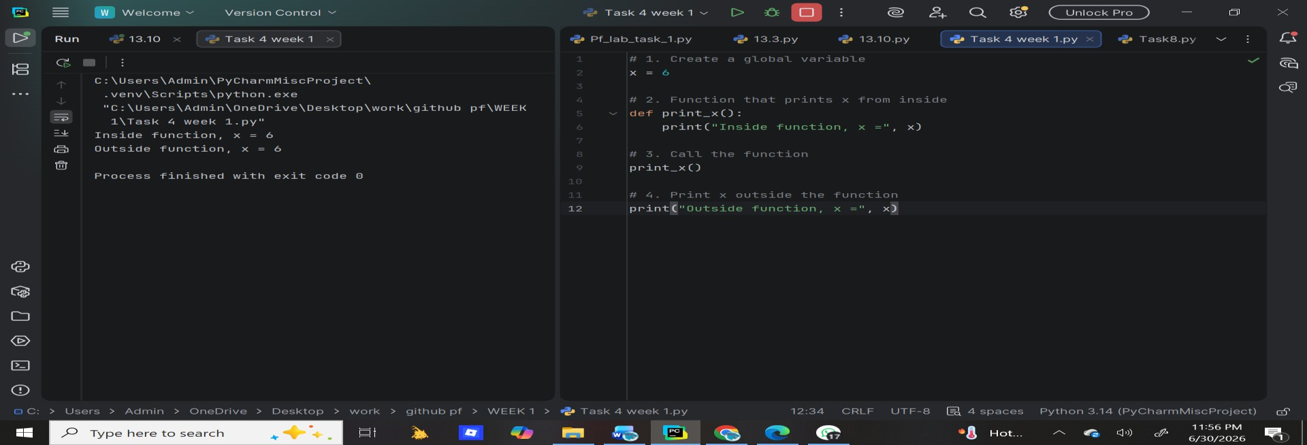
Result:

Task2:

Create a function that defines a local variable y = 5 and prints it inside the function. Try to print y outside the function and observe the error.
Result:
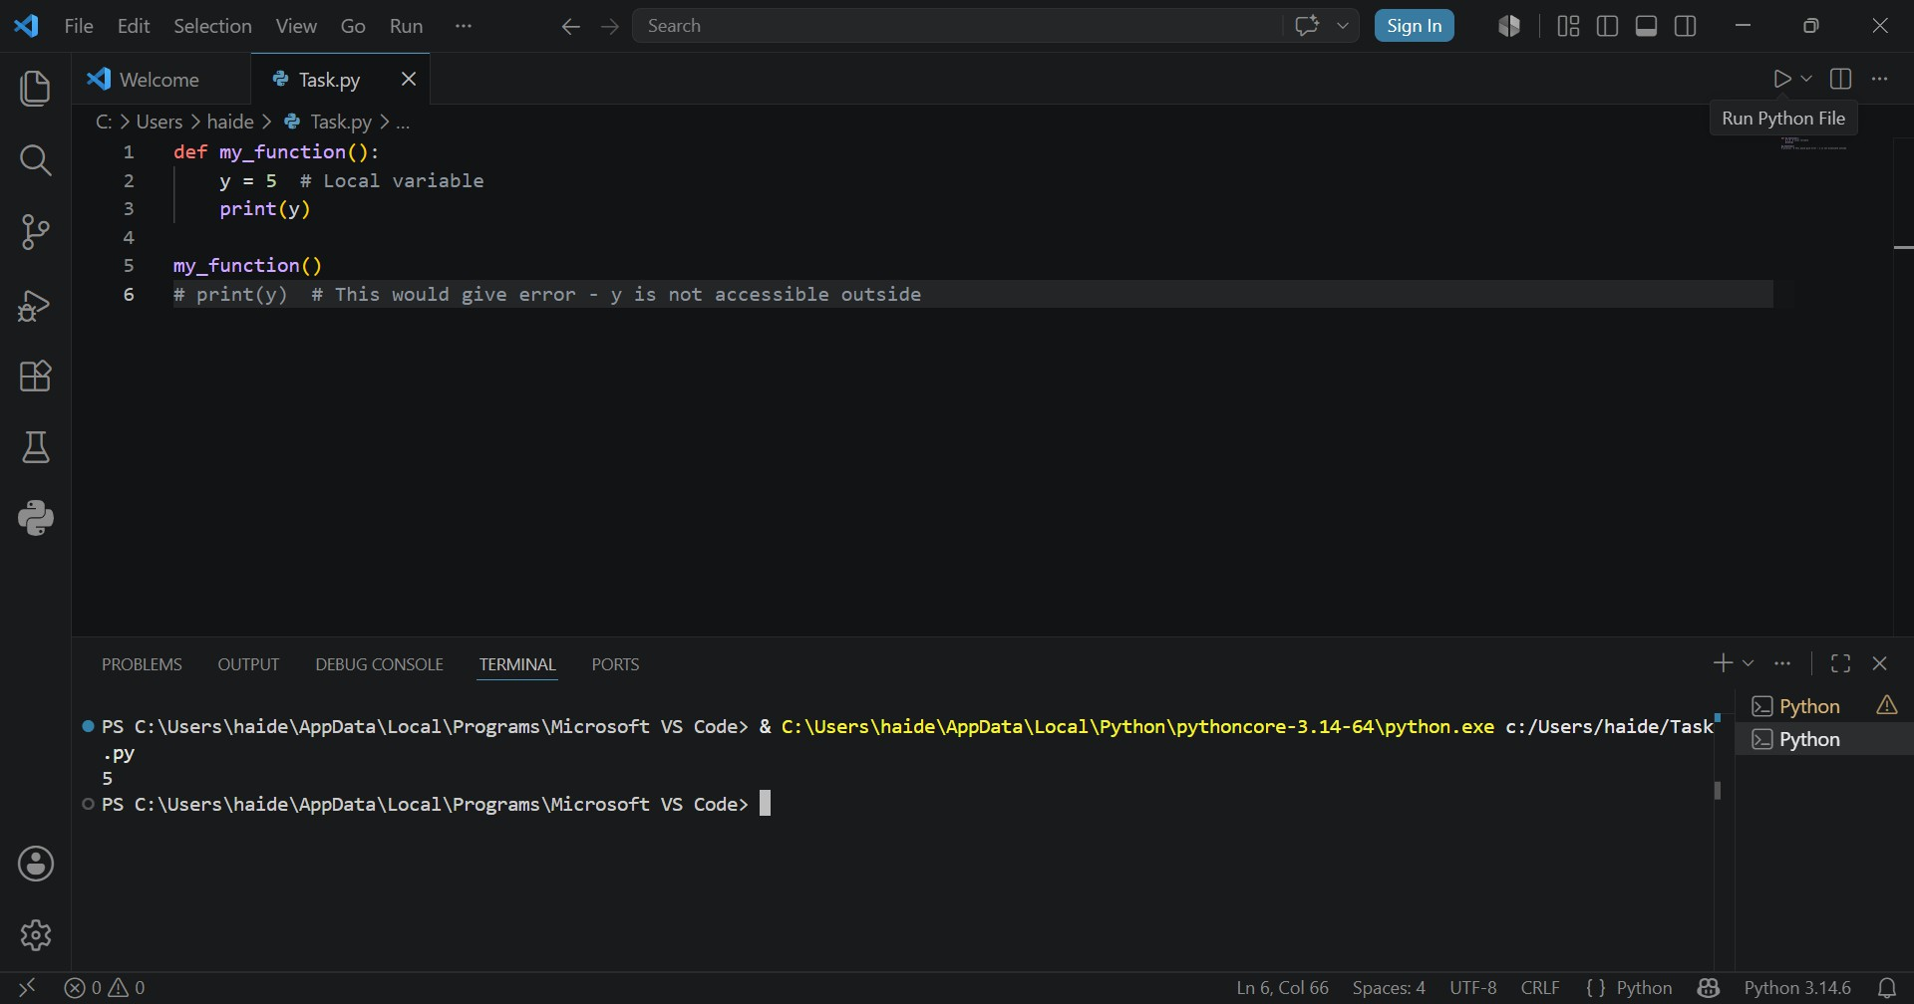

Task 3:
Create a global variable name = "shayan". Inside a function, create a local variable with the same name name = "Sara". Print both inside and outside the function to see the difference.

Result:
Task 4:
Create a global variable count = 0. Write a function that increments count by 1 using the global keyword. Print the value inside and outside the function.

Result:

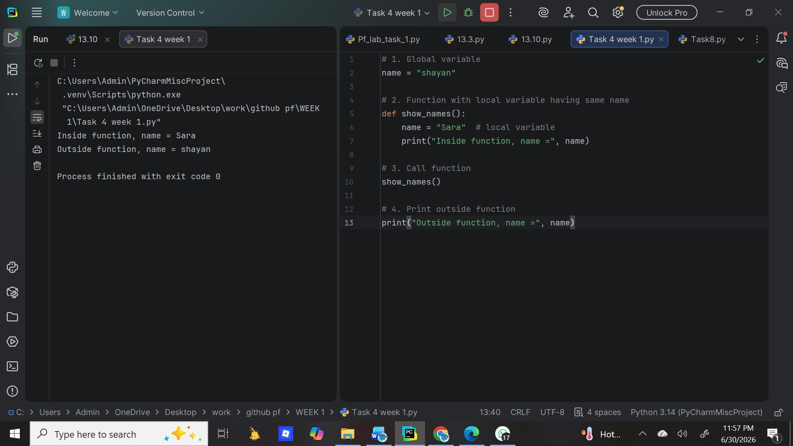

Task 5:
Create a global variable total = 80. Inside a function, define a local variable discount = 20 and calculate the final price using both variables. Print the result inside the function and print the original total outside.

Result:
Task 6:
Create a global variable number = 5. Write two functions - one that prints the square of the number and another that prints the cube. Use the global variable inside both functions.

Result:

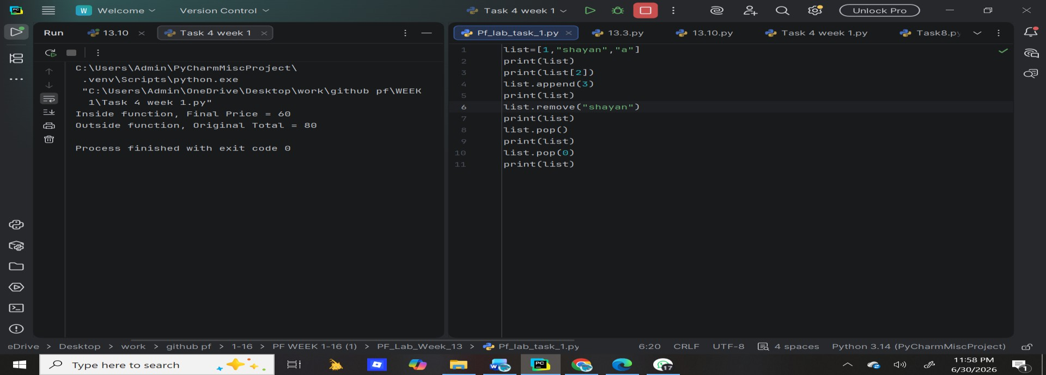

Conclusion:
- Local variables are safer and preferred because they avoid conflicts. Each function manages its own data, so one function cannot accidentally change another function's data.
- Global variables are useful when many functions need to share the same data, like configuration settings. But overuse can make code hard to debug because any function can change them.
- Best Practice: Use local variables as much as possible. Use global variables only when necessary, and keep their number small.

